RADIAL DISTRIBUTION OF POINT DEFECTS IN CZ SILICON

L. Válek, M. Lorenc and J. Šik

ON SEMICONDUCTOR CZECH REPUBLIC, Rožnov p. R., lukas.valek@onsemi.cz

Yield, performance and reliability of devices manufactured on Czochralski (CZ) silicon wafers are impacted by the presence of various defects. While their occurrence in the device area is deleterious, they act beneficially outside the device zone by gettering the metallic impurities [1]. Control of defect type, size and spatial distribution is the subject of defect engineering. The task of this paper is to introduce the contents of defect engineering and show the significance of computer simulations for this work.
Defects in CZ silicon develop during crystal growth and subsequent thermal processing especially from intrinsic point defects and interstitial oxygen [2]. Vacancies (v) and interstitials (i) incorporate into the crystal on the melt-crystal interface. Their flux from the interface is determined by the motion of growing crystal and diffusion against the temperature gradient in the crystal. Equilibrium concentration of vacancies C_{v}^{eq} at the melting temperature (T_{m} = 1412°C) is higher than the concentration of interstitials C_{i}^{eq} (C_{v}^{eq}(T_{m})/C_{i}^{eq}(T_{m}) = 1,07). Convective flux of vacancies at the same growth rate V is thus higher than that of interstitials. On the other hand diffusion coefficient of vacancies D_{v} is lower than that of interstitials D_{i} (D_{v}/D_{i} = 0,71), therefore diffusion flux of vacancies at the same axial temperature gradient is lower than that of interstitials. Consequently the ratio of growth rate V and axial temperature gradient G on the melt-crystal interface determines the ratio of vacancies and interstitials fluxes. During cooling of the crystal down to approximately 1300°C interstitials recombine with vacancies until only one type of point defects remains. The V/G ratio therefore determines if vacancies or interstitials dominate in the grown crystal at this temperature [3]. If V/G is higher then the critical value (V/G)_{crit}, then vacancies prevails, otherwise the crystal is of interstitial type. During further cooling of the crystal, prevailing point defects become supersaturated; they agglomerate and react with oxygen forming oxygen precipitates, interstitial dislocation loops or vacancy clusters. Resulting types, size and density of these defects depend strongly on the type and concentration of prevailing point defect and hence on the V/G ratio during crystal growth.
In order to control defects in the crystal through V/G ratio, we must know these variables. The growth rate V is assumed to be constant across the melt-crystal interface and as such can be approximated well by the crystal pull rate. The value of temperature gradient G on the interface must be determined by computer simulation. We use the FEMAG software [4] for simulations of the global temperature field in the puller and growing crystal. Typically the G value is radially dependent and due to faster cooling of the crystal periphery it increases with the radius. The V/G(r) ratio then decreases from the crystal center to the rim (r – radius). The value of (V/G)_{crit} depends on the dopant type and concentration, and concentration of interstitial oxygen [3]. Since the dopant and oxygen concentration varies along the crystal, (V/G)_{crit} must be determined in dependence on the crystal length. It varies typically in the range 0,1 - 0,3 mm²/min.K. From the known dependence of the pull rate on crystal length and a series of simulations of the temperature field for different crystal lengths we are able to construct the V/G(r) shapes along the crystal length. Comparing them with corresponding (V/G)_{crit} crystal parts of vacancy, interstitial or mixed type can be identified.
a) b)

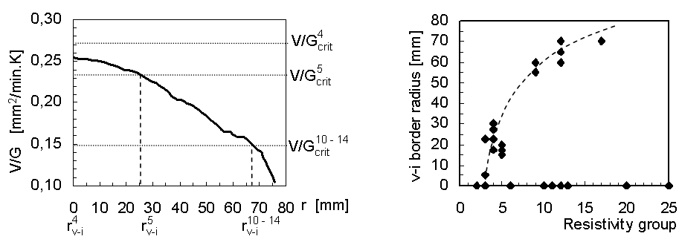
Fig. 1: a) Computer simulated radial dependence of V/G for a crystal length L. Critical values of V/G for several dopant concentrations (represented by the resistivity, denoted by number of resistivity group in superscript) are shown together with corresponding theoretical radius of vacancy – interstitial boundary (r_{v-i}). b) Radius of vacancy – interstitial (v-i) boundary measured on the crystal length L for crystals with different dopant concentration (resistivity decreases with group number).

Fig. 1 shows an example of defect engineering work. From Fig. 1 a) we see that (V/G)_{crit} for crystals from resistivity group 4 is higher than the actual V/G over all crystal radius. Hence silicon self interstitials should be dominant point defects in the entire cross-section of group 4 crystals (at the simulated crystal length). The simulated V/G for crystals from group 5 is lower then (V/G)_{crit} on the radius of 0 – 30 mm. Vacancies should be dominant in this part of crystals while the outer crystal part should be of interstitial type. Crystals from higher groups (10 – 14) should be of vacancy type almost over the entire radius, because only small part of the crystal at the rim has V/G lower than (V/G)_{crit}.
Let us now compare computer simulations with experiment shown in Fig. 1 b). The radius of v-i boundary for lower groups (2 – 6) varies from 0 to 30 mm, which corresponds to the r_{v-i}⁴ - r_{v-i}⁵ range determined from simulations. On the other hand v-i boundary for higher groups (10 – 14) lies close to the crystal rim (crystal radius is 76 mm), which approximately corresponds to computer prediction r_{v-i}¹⁰⁻¹⁴. Zero values of measured r_{v-i} mean that no v-i boundary was found. This can be explained as follows: for lower groups vacancy area can shrink to the center while for higher groups it can spread over the entire wafer. High variance of measured v-i values can be attributed to fluctuations of the pull rate, dopant and oxygen concentration among the analyzed crystals.
The agreement of computer simulations with experimental observations of vacancy -interstitial boundary was demonstrated. Computer simulations help to explain behavior of defects in variously grown crystals and allow predicting and controlling of defects distribution in CZ grown silicon crystals.

[1] M. Lorenc, L. Válek, V. Pešat: Silicon wafer gettering ability studied by the method of controlled contamination, in these Proceedings.
[2] J. Šik, Z. Bochníček: Oxygen precipitation in Czochralski silicon, in these Proceedings.
[3] G. Borionetti, D. Gambaro, M. Porini and V. V. Voronkov: Electrochemical Society Proceedings Semiconductor Silicon 2002-2, 505.
[4] www.femagsoft.com.

